

MSE801 – Research Methods
Assessment Submission (Tasks 1–3)
Student: Wijemuni Rukshan Madushanka De Silva
Student ID: 270802602
Research Topic:
Effectiveness of AI-Based Tools in Software Defect Prediction

Task 1: PRISMA Diagram with Inclusion and Exclusion Criteria
The current research follows the PRISMA framework in a systematic way of identifying, evaluating, and including studies that are relevant to the effectiveness of AI tools in defect prediction within software engineering. The PRISMA framework has been chosen for this purpose because of its transparent, systematic, and replicable approach to conducting a systematic review, which is critical in maintaining academic rigor and avoiding bias in software engineering research.
PRISMA provides a framework that facilitates the documentation of the decision-making process in each stage of the review. This improves the credibility of the review, making it easier to replicate or evaluate the research process.

PRISMA Flow Diagram
Figure 1 presents the PRISMA flow diagram illustrating the study selection process used in this systematic literature review.
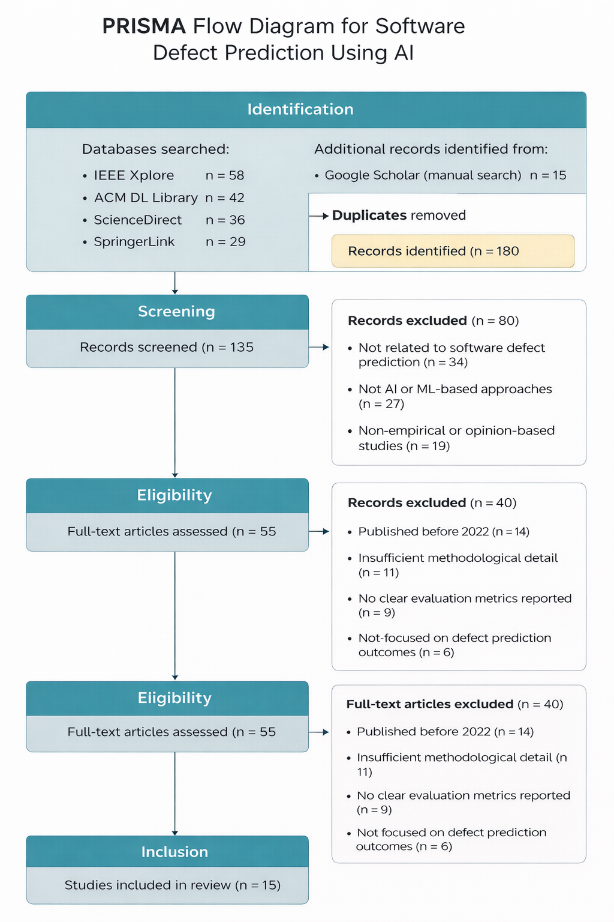
Figure 1. PRISMA flow diagram illustrating the identification, screening, eligibility, and inclusion of studies related to AI-based software defect prediction

PRISMA Flow Explanation
In the identification phase, records were collected from various academic databases, such as IEEE Xplore (58 records), ACM Digital Library (42 records), ScienceDirect (36 records), and SpringerLink (29 records). In all, a total of 165 records were collected from these academic databases. To obtain more records, the researchers also performed a manual search using Google Scholar, increasing the number of records to 180.
In the screening phase, duplicate studies (n=45) were eliminated to ensure the accuracy of the results. The remaining 135 studies were subjected to a title and abstract screen to check their relevance to the topic of AI-based software defects. In this phase, a total of 80 studies were eliminated due to reasons such as non-relevance, lack of use of AI or ML, and non-empirical focus.
The eligibility phase consisted of the evaluation of 55 studies based on their full text. The studies were then subjected to inclusion and exclusion criteria to assess their quality. Out of the 55 studies, 40 were excluded for reasons such as being published prior to 2022, lack of adequate methodology, and the absence of evaluation metrics.
Finally, during the inclusion phase, there were 15 studies that met all the eligibility criteria, which were included in the final systematic review. This formed the basis of analyzing the current AI-based approaches used in software defect prediction.

Inclusion Criteria
The inclusion criteria were defined to ensure that selected studies were relevant, current, and methodologically sound:
- Peer-reviewed journal articles
- Publications between 2022 and 2025
- Focus on artificial intelligence, machine learning, or deep learning approaches for software defect prediction
- Empirical studies with clearly reported methodologies and evaluation metrics
- Articles written in English

Exclusion Criteria
Studies were excluded based on the following criteria:
- Publications released before 2022
- Opinion-based papers, editorials, or tutorial articles
- Research not directly related to software defect prediction
- Studies lacking sufficient methodological detail or evaluation results
- Duplicate publications

Task 2: Research Flow Diagram
The research methodology for this project is based on a structured and systematic approach that is in line with the best practices in software engineering research methodologies. The methodology starts with the formulation of a research problem that deals with the efficacy of AI-based tools in software defect prediction. Then comes the literature review based on the PRISMA protocol.
Next, data will be extracted from the selected studies and synthesized qualitatively to identify trends, strengths, and weaknesses of various AI-based methods. Finally, the research flow for software defect prediction using AI-based methods concludes with the interpretation of results, limitations, and recommendations for conducting further research in the area of software defect prediction.
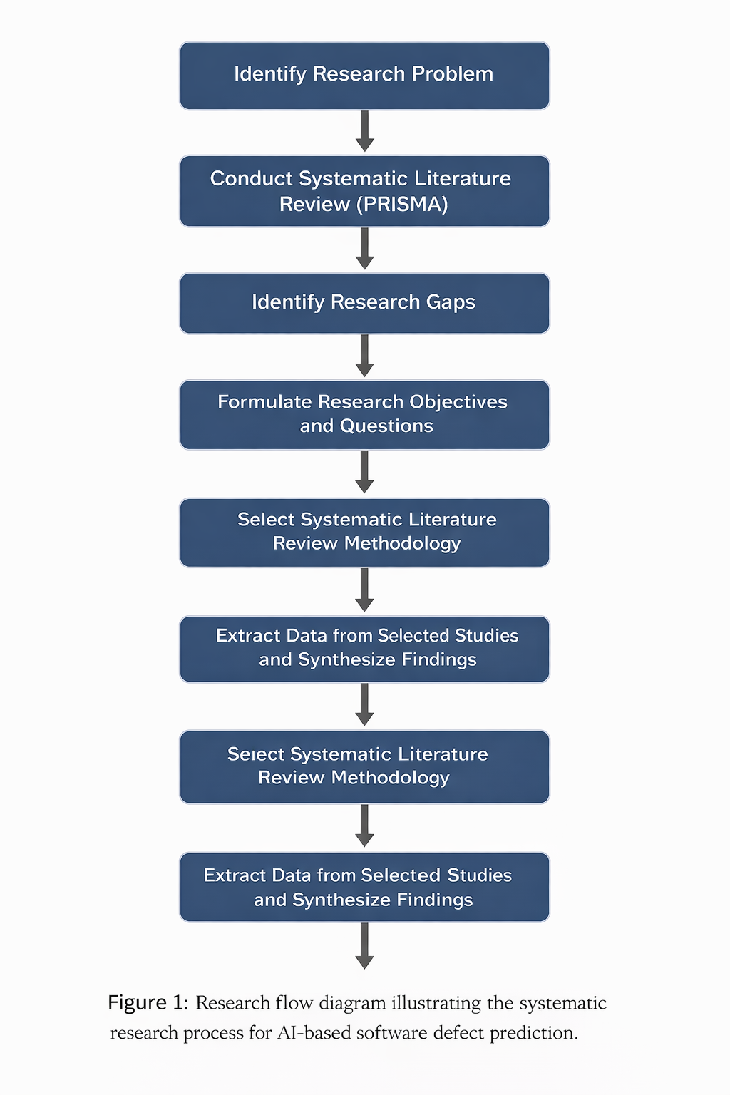
Figure 2. Research flow diagram illustrating the systematic research process for AI-based software defect prediction.
The research flow diagram illustrates the systematic research process adopted for this study, commencing with the identification of the research problem and advancing through a systematic literature review based on PRISMA guidelines. The research process is then focused on identifying gaps in research, synthesizing data from specific research studies, and interpreting research findings.

Task 3: Research Completion Timeline

A structured completion timeline has been developed to ensure that the research methods project is completed in an efficient manner within a given time frame. The milestones are identified on this timeline. Sufficient time is allocated to each research activity.

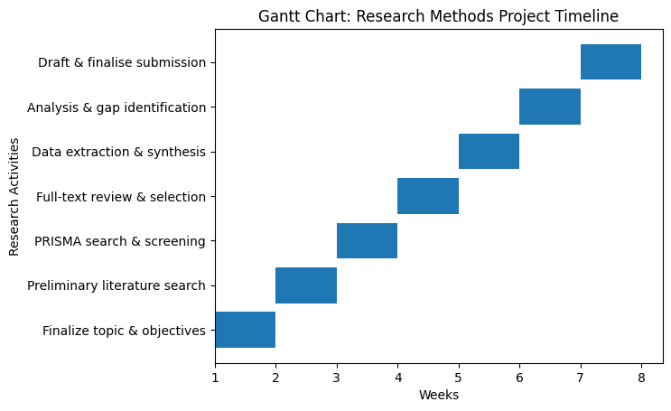
Figure 3. Gantt chart illustrating the timeline for the research methods project.
The Gantt chart gives an overview of the research activities to be conducted, and the period involved in the research process, indicating how the research process will be well organized and achievable to ensure proper time management in the research methods project.

Week | Activity | Detailed Description
Week 1 | Finalize research topic and objectives | Confirm the final research topic related to AI-based software defect prediction. Clearly define the research scope, objectives, and alignment with software engineering research requirements.
Week 2 | Conduct preliminary literature search | Perform an initial search across academic databases (IEEE Xplore, ACM Digital Library, ScienceDirect, SpringerLink) to understand existing research trends and refine search keywords.
Week 3 | Apply PRISMA search and screening process | Conduct systematic database searches using defined keywords. Remove duplicate records and screen studies based on titles and abstracts following PRISMA guidelines.
Week 4 | Full-text review and study selection | Retrieve and review full-text articles. Apply inclusion and exclusion criteria to assess methodological quality and relevance and identify eligible studies for the review.
Week 5 | Data extraction and synthesis | Extract relevant data from selected studies, including AI techniques, datasets used, evaluation metrics, and key findings. Organize extracted data for qualitative synthesis.
Week 6 | Analysis of findings and identification of research gaps | Analyze extracted data to identify patterns, strengths, limitations, and research gaps in current AI-based defect prediction approaches.
Week 7 | Drafting and finalizing the research methods project | Compile the PRISMA diagram, research flow diagram, and timeline. Review content for clarity, coherence, and alignment with assessment requirements before final submission.
Figure 4. Timeline Table

